|  |  |
| --- | --- |
| **Primary Media Contact:**  **Advantech Co., Ltd./ IAG Marketing**  **Sally Huang**  **Product Marketing**  **Tel: +886-2218-4567 Ext: 2633**  [**Sally.huang@advantech.com.tw**](mailto:Sally.huang@advantech.com.tw) | **2nd Media Contact:**  **Advantech Co., Ltd./ IAG Marketing**  **Stuart Carruthers**  **Marketing Writer**  **Tel: +886-2-2792-7818, Ext.2674**  [**Stuart.Carruthers@advantech.com.tw**](mailto:Stuart.Carruthers@advantech.com.tw) |

Advantech Introduces New 18.5” Widescreen Multi-touch Flat Panel Monitors

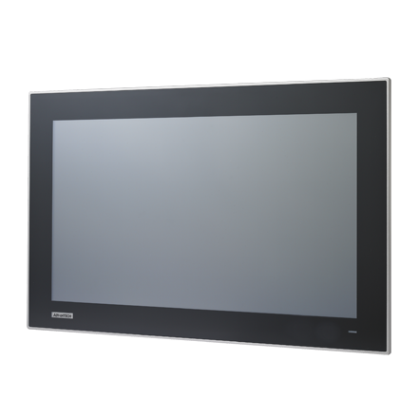

***Taipei, Taiwan – [June, 2013]***– The FPM-7181W and FPM-7211W are 18.5” and 21” widescreen multi-touch truly flat panel monitors, specifically designed to provide easier operation and boost productivity in manufacturing control environments, building automation and other HMI applications.

Designed with the same elegant design as the new widescreen TPC models, the FPM range have an attractive and functional truly flat widescreen and a ratio of 16:9, providing 40% more screen area than 4:3 displays. In order that the models can be cleaned and operated in a wide range of environments both models are IP65 certified so that they are dust-tight and protected against jets of water.

Furthermore, with the addition of four-finger multi-touch capabilities they provide even greater control and viewing of the information shown.

As with all Advantech flat-panel monitors these two can be mounted on panels or on walls, providing a range of options for any industrial environment.

The FPM-7181W is available now and the FPM-7211W will be available at the end of July.

To find out more about how these models can be used in your business, contact your local sales representative or go to [www.advantech.com](http://www.advantech.com).

###

Abstract

**Advantech Co., Ltd. - Industrial Automation Group –** Founded in 1983, the Industrial Automation Group has grown into a global business organization with more than 30 branch offices in 17 countries, and a worldwide partner network comprised of leading Automation corporations. As a pioneer in open Automation technology, Industrial Automation Group is proud of its efforts as global stewards; providing vertical-focused products, solutions and value-added services for a wide array of sectors, including; Building Automation, Machine Automation, Power & Energy, and Intelligent Transportation Systems. ([www.advantech.com.tw](http://www.advantech.com.tw/)).