|  |  |
| --- | --- |
| **Primary Media Contact:**  Advantech Co., Ltd.  Tiffany Chou  Tel: +886-2-2792-7818, Ext. 7982  [Tiffany.Chou@advantech.com.tw](mailto:Tiffany.Chou@advantech.com.tw) |  |

**Advantech Launches PIT-1503W, Full-flat Patient Terminal at Intelligent Planet & Internet of Things Expo**

***Patient Infotainment Systems are a Hospital’s Choice for Quality and Service***

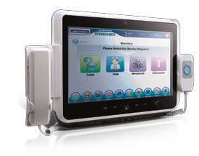**Taipei, Oct 25, 2011** – Advantech, a leading service and solution provider, announced the PIT-1503W Patient Infotainment Terminal during its Intelligent Planet & Internet of Things Expo from Oct. 26th to 29th. PIT-1503W runs an Intel® Atom™ D510 processor and is designed with a 15.6” wide, projective capacitive touch (PCT) full-flat glass panel. It has a sleek iPad look and feel, with customizable colors and icons. The panel design is durable and easily cleanable with anti-bacterial cleaners, perfect for use in hospital patient rooms. It is lightweight and slim, easy for patients to move, and personnel to stow, and it can bring entertainment as well as information to the patient bedside, increasing efficiency, improving patient wellbeing, and even adding revenue streams to the hospital. The proven technology is running successfully in hospitals around the world and migration from the PIT-1502W is transparent, as all applications will easily port to the new system.

**Multi-touch, Durable Function Keys and Full-flat Glass Panels: Easier to Use and Clean**

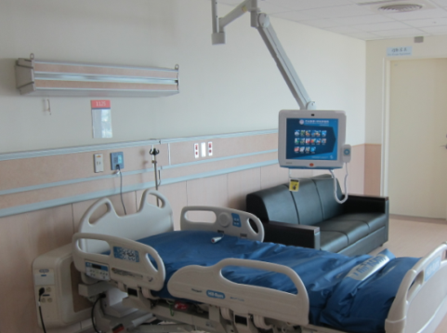PIT-1503W features PCT touch technology, a quick and highly accurate multi-touch system. Running Windows 7 or Linux, two-finger multi-touch can be used to rotate, flick images off-screen or zoom in and out. This allows for easy zooming and rotation of X-ray or patient images during a patient consultation. The full-flat panel is 7H-rated. It is highly resistant to scratches and can be kept clean with hospital-grade anti-bacterial cleaning solutions. Function keys are also accessible from under the glass panel and not subject to the wear and tear that can afflict membrane-covered keys. Light transmission of PIT-1503W’s PCT screen is excellent (90% compared to 80% from resistive touch technologies) and the increased multi-touch sensitivity makes it responsive as well as intuitive.

**Customizable, Sleek iPad “Look” and Modular Peripheral Support Runs Your Specific Applications**

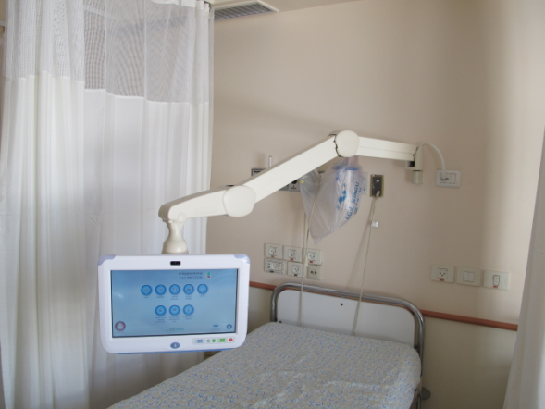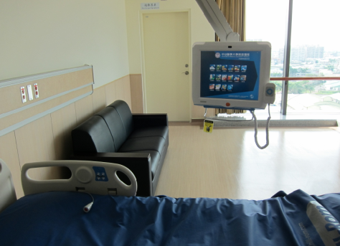PIT-1503W has been designed with a sleek iPad-like look. The unit’s color can be customized as can its button icons so that it fits the specific requirements of different hospitals. But PIT-1503W doesn’t stop at good looks. It supports a host of peripherals: RFID, CCD, Wi-Fi connectivity, TV tuner and Smartcard reader. This allows the hospital to configure the device to their liking, where PIT-1503W can run applications ranging from movies-on-demand and VOIP for the patient, to connectivity to X-ray and hospital medication systems for hospital staff. With PIT-1503W in the room, authorized providers, patients and medications can all be positively identified and matched. PIT-1503W is perfect for family and patient meetings. It is used by phlebotomy technicians to manage the drawing and analysis of blood. And patients can use smartcards to access premium functions, watch movies, order food from in-hospital convenience stores, browse the web, or call friends and family. When not in use, the lightweight unit folds flat against the wall on a convenient wall-mount extension arm.

**Real-world Stories of Success Lead to Increased Revenue, Better Efficiency, and More Intelligent Technology Solutions in Hospitals**

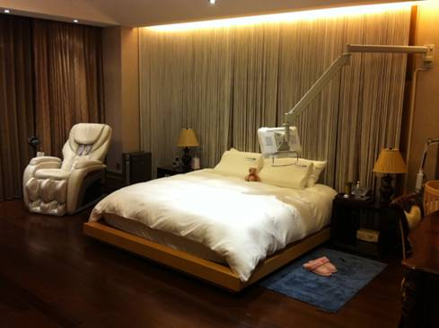In hospitals around the world, service-quality and intelligent technology is becoming an important metric of success. PIT-1503W and Advantech Healthcare products are in some of the most elite hospitals adding to their success. In Israel, the Clialit Health Services association is using Advantech products in more than 14 hospitals and 1,200 primary and specialized clinics to modernize TV systems, and provide internet access and VOIP in a fee-based model which brings revenue to the hospital. In Beijing, a post-delivery maternity center has equipped its rooms with PIT-1503W terminals to provide entertainment options to new mothers and their families. Post-delivery care centers in China look more like 5-star hotel rooms than a medical facility and the patients are in the care of the provider for an extended time; a nurturing and inviting environment is important to their success. Lastly, in Taiwan, the Chung Shan Medical University Hospital has built what is being billed as Taiwan’s first comprehensive intelligent state-of-the-art hospital, using Advantech to tailor digital signage systems and bedside infotainment terminals so that they work seamlessly with other hospital information systems; truly transforming technologies into intelligence.

PIT-1503W is available now. In the near future Advantech will be releasing the PIT-1703W, for applications demanding more on-screen space. For more information about Advantech Patient Infotainment Terminals, please contact an Advantech sales representative, or visit the website at: [www.advantech.com](http://www.advantech.com).

###

**About Advantech**

Founded in 1983, Advantech is a leader in providing trusted, innovative products, services, and solutions. Advantech offers comprehensive system integration, hardware, software, customer-centric design services, embedded systems, automation products, and global logistics support. We cooperate closely with our partners to help provide complete solutions for a wide array of applications across a diverse range of industries. Our mission is to enable an intelligent planet with Automation and Embedded Computing products and solutions that empower the development of smarter working and living. With Advantech, there is no limit to the applications and innovations our products make possible. (Corporate Website: [www.advantech.com](http://www.advantech.com/)).